XCOM 2 Analysis

Product Details

Attributes

* The game was released on PC, and later PlayStation 4 and Xbox One
* It is a tactical, turn-based strategy game
* It had 500,000 sales on Steam in the first week, and peaks at 8,000 people every month

Overview

*“Earth has changed. Twenty years have passed since world leaders offered an unconditional surrender to alien forces. XCOM, the planet’s last line of defense, was left decimated and scattered. Now, in XCOM 2, the aliens rule Earth, building shining cities that promise a brilliant future for humanity on the surface, while concealing a sinister agenda and eliminating all who dissent from their new order.” - Steam description*

XCOM 2 is a turn-based strategy game where you have control of a mobile operations base and can send teams out on missions. The base can travel around the world, and you have full control over what you build inside it. You also have full customisation of the soldiers and can specialise them into five different classes, which allows you to bring varied combinations for different mission situations. With the goal of taking back control of the planet, the player must make tough decisions, juggle a variety of scarce resources, and fight the clock to succeed.

Target Market

The target audience for XCOM 2 are people who enjoy:

* Challenging strategy games
* Consequences for in-game choices
* Long game experiences
* Sci-fi and dystopian adventures

It is also aimed at:

* More mature/developed gamers, as it’s a punishing game and is expensive (main game - $90 dlc - $55)
* Players of the first game

Unique Selling Point

The first XCOM game was about a secret government agency defending Earth from the alien invaders. The special thing about XCOM 2 is that the aliens have already defeated Earth and you control a more militia-like force, performing operations to create a rebellion and tear down the new alien-controlled society.

The game factors that make it unique:

* Really tight and defined game rules
* Deterministic and chance-based gameplay that blends reliable systems and risk vs reward scenarios

Gameplay Details

Game Objectives

* Manage limited resources
* Defeat the alien overlords
* Win before time runs out (Avatar Project)

Core Experiences

* Tension
  + Actions have consequences
  + Strong characters can permanently die
* Strategy
  + Must think about many aspects at once:
    - Base layout/upgrades
    - Soldier maintenance
    - Player goals
    - Enemy time limits
    - Research
  + The combat is deep and requires thinking many steps ahead

Key Mechanics

* **Avenger (Mobile Operations Base)**
  + Can travel to a few regions on the continents, and mission locations
  + Has static rooms that cannot be altered (research, armory, command centre, etc.)
  + Has many room slots that you can clear to place new rooms with different effects
  + Can be attacked by an AI UFO
* **Upgrades**
  + There are tiers of armour that give higher defence
  + Tiers of weapons that do more damage and have more equipment slots
  + Each character gains levels and you get to choose different abilities
* **Missions**
  + You control 1-6 characters
  + Grid based movement system
  + There is a zone around you dictating how far you can move
  + You can move once and perform an action, or dash by moving twice with no action
  + All the player’s characters move, then the alien AI
  + There is a fog of war that uncovers according to characters line of sight
* **Combat**
  + If a character is next to or behind an object, they get a cover defence bonus
  + Characters can only shoot enemies in line of sight
  + There is a base chance to successfully hit a shot which is affected by cover, distance, status effects, high ground
  + There are grenades that have an area of effect
  + Characters receive critical damage if flanked
* **Avatar Project**
  + A project that the aliens are completing as you play the game
  + Has 12 progress squares and when it reaches 12 you lose
  + Gains squares over time
  + Completing some missions halt progress or remove squares

Gameplay Loops

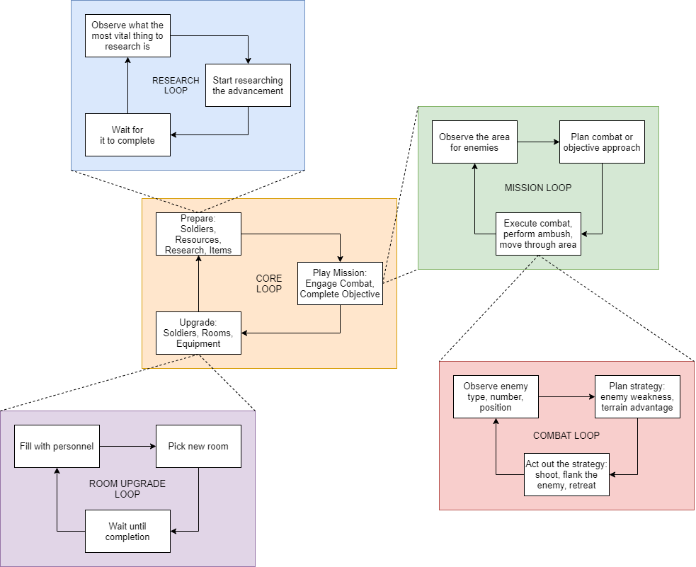

Critical Analysis

XCOM 2’s extremely in depth systems and mechanics create a very satisfying gameplay experience, because victories feel deserved and in defeat the player knows they could have avoided it with a better strategy.

The game allows for many different playstyles, as with the saving system one could essentially turn back time to before all of their soldiers died. In XCOM you can save at any time, which enables the bad and average players to change their strategies on the fly and still have fun, whilst letting the good ones accept their actions and deal with the consequences.

One downfall of the game is the presence of several bugs such as the bug that prevents players from setting up an ambush, since the enemy AI stops moving once in the players’ line of sight. Something like this ruins the core experience, because the game is based upon a strict set of rules that the player relies on to form their strategies.